**[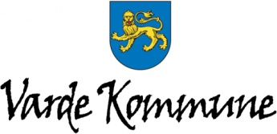](http://www.vardekommune.dk/)**

**Annual Meeting Program**

Nymindegab Kro [www.nymindegabkro.dk](http://www.nymindegabkro.dk)

**[Nymindegab-kro-logo_clean.png](http://www.nymindegabkro.dk/)**Nymindegab, March 9-10, 2015

**Monday March 9:**

* 10.30-12:00 Board meeting at Nymindegab Kro
* 12:00 Arrival, check-in and lunch for all others
* 13:00 Welcome by Tommy

Introduction by Poul Sig Vadsholt (Varde Municipality) and Claus Christensen, (Chairman for Sydvestjydsk Landboforening)

* 13.30 Bus trip to Filsø

(Lunde Turistbus, pick-up in front of Nymindegab Kro).

**See full program in Danish below**.

Introduction to Filsø in the bus by Merete Vigen Hansen ([www.meretevigen.dk](http://www.meretevigen.dk))

* 14.00-14.45 Walk- and story-telling about Filsø on location (2 places)
* 14.45-15.00 Visit at pig farmer Asger Pedersen, in the dNmark case study area
* 15.00-15.15 Coffee and bread
* 15.15-16.00 Presentation of the project on differentiated land area regulation (Peder Chr. Thomsen, Irene Wiborg and Nikolaj Ludvigsen)
* 16.15-16.15 Bus trip through the landscape
* 16.15-17.00 Focus on organic farming. Visit to the I/S Kristensen organic dairy farm (Discussion on Nitrogen challenges in organic production, with special inputs from professor Jørgen E Olesen and the farmer)
* 17.00-17.15  Bus trip in the landscape
* 17.15 -17.30 Stop at Nøreng Plantage (Kærgaard Klitplantage). Team leader Klaus B Fries (Varde Kommune) presents Naturpark Vesterhavet and the project ”story-telling about nature”. Potential Red Deer (Krondyr) Royal Stag Safari.
* 17.30-17.50  Bus drive back to Nymindegab Kro
* 19:00 Dinner at Nymindegab Kro.

Including interesting reflections about N-food prints and the menu

(By Morten and Sandy)

* Mingling and social evening activities

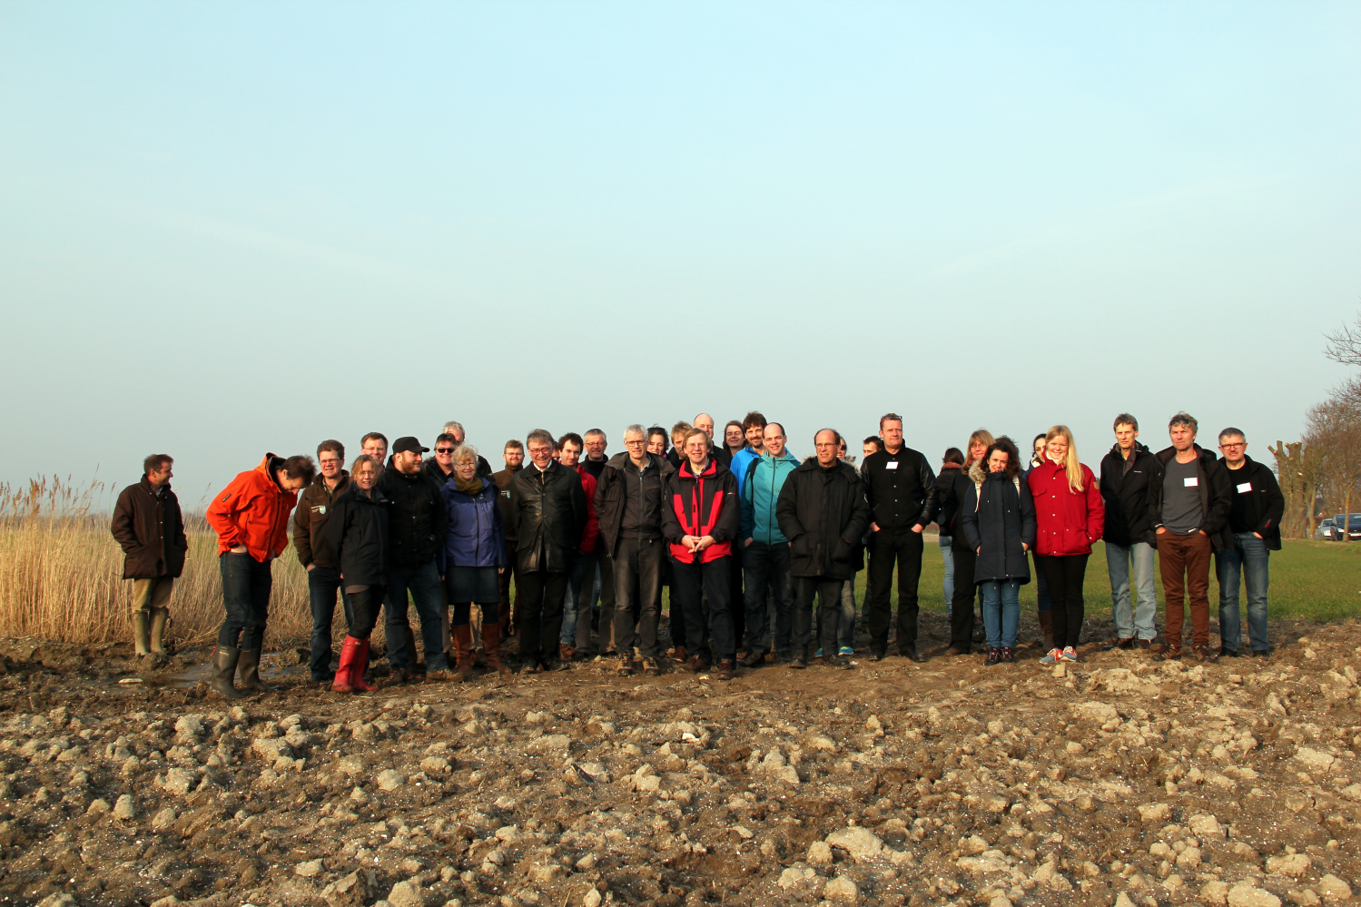

**Tuesday March 10:**

* 9:00 Welcome by Mayor for Varde Municipality (Erik Buhl Nielsen)
* 9:15 Short project status (Tommy, RC6)
  + Board meeting report, wind-up from previous meetings etc.
  + Introduction to the annual meeting program
* 9:30 -9:50 Results from the pilot project for new land area regulation by Nikolaj Ludvigsen (Danish EPA, Ministry of Environment ) and Irene Wiborg (SEGES)
* 9:50-10:00 Nitrogen measurement results from the Hagens Møllebæk dNmark study site in Skive (by Jane Bang Poulsen, Aarhus University, Bioscience).
* 10:00-10:15 Coffee Break
* 10:15 – 12:00 **Targeted regulation of agriculture – new knowledge results from dNmark; presentation and discussion**
  + 10:15-10:35: Solution scenarios, with special focus on the scenario targeted differentiated regulation in dNmark – discussion and food for thoughts (Jørgen E. Olesen, RC1 and RC6)
  + 10:35-11:00 Results from the local workshops, and the Landscape scenario GIS platform to be tested during the next round of workshops in the local case study areas (Henrik Vejre, Peter Stubkjær Andersen and Andreas Aagaard Christensen, RC2).
  + 11:00-11:45 Targeted regulation – cost effectiveness modelling by different approaches (Brian Jacobsen and Berit Hasler, RC3)
  + 11:45-12:00 Discussion and summary (Chaired by Jørgen E Olesen)
* 12:00 – 12:45 Lunch
* 12:50 – 14:10 PhD and post-doc café workshop (RC4)
  + 12:50-12:55 Short introduction by Berit Hasler
  + 12:55-14:00 Café table workshop where dNmark-experiments are introduced (Café table holders are all PhD and post docs)
* 14:00-14:10 Short break
* 14:10-14:45 official approving of the communication plan 2015+, and input for project result dissemination and real world implementation. (Irene, RC5)
  + 14:15-14:35 Brain storm in groups: Ideas for spin off projects from the dNmark studies
  + Short reports from the groups (organized by Irene)
* 14:45 – 15:00 dNmark activities during the next year, and wrap-up (Tommy)
  + International workshop and dNmark bi-annual meeting in Aarhus, October 5-6 2015
  + Next dNmark annual meeting in Foulum, March 14-15 2016
  + 15:00 Good bye, coffee and possibility for RC component meetings

**[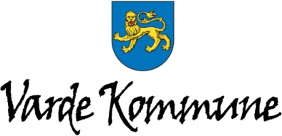](http://www.vardekommune.dk/)Program for faglig ekskursion**

***Den 9/3 2015 kl. 13.30-18.00***

13.30 Bus afgår fra Nymindegab til Filsø (Lunde Turistbus)

Orientering om Filsø undervejs (v/ Merete Vigen Hansen [www.meretevigen.dk](http://www.meretevigen.dk)).

14.00-14.45 Besigtigelse og fortælling om Filsø v. Merete Vigen Hansen (Freelance Kultur- og naturformidling, medlem af Aage V Jensen Fondens bestyrelse for Filsø og hovedbestyrelsen for Danmarks Naturfredningsforening).

14.45-15.00  Kørsel til svineproducent Asger Pedersen, Nymindegabvej 181, Outrup.

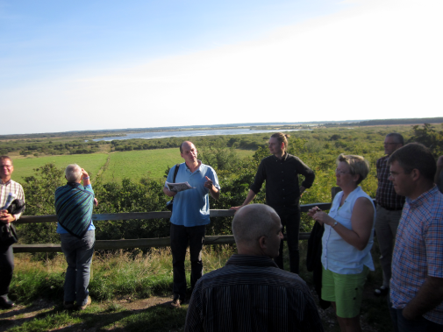

Orientering om projektområdet ved Peter Stubkjær

og Tommy i bussen undervejs.

15.00-15.15  Kaffe + brød

15.15-16.00  Projekt om areal-regulering.

Asger Pedersen har været med i projektet om ny arealregulering. Temaet vil være den ny arealregulering med input fra deltagende landmand Asger Pedersen, lokal Miljørådgiver Peder Christian Thomsen (JYSK), SEGES Planter og Miljø (Irene) og Miljøstyrelsen (Nikolaj Ludvigsen).

16.00-16.15  Kørsel til økolog Flemming Kristensen fra I/S Kristensen, Søndersøvej 80, 6854 Henne. Evt. lidt kommentarer i bussen.

16.15-17.00  Fokus på økologi – drøftelse af muligheder.

I/S Kirstensen driver et økologisk malkekvægbrug. Temaet for besøget er aftalt at være: udnyttelse og tab af N-ressourcen på økologiske landbrug. Hvilke overvejelser gør landmanden, og hvad viser forskningen?

Input fra landmand og forsker (Professor Jørgen E Olesen, AU), vedr. målinger af udvaskning fra økologiske sædskifter med kløvergræs og indtænkning af virkemidler til at holde på kvælstof.

17.00-17.15  Kørsel

17.15 -17.45 Stop ved formidlingspunkt Nøreng Plantage (Kærgaard Klitplantage), hvor Varde Kommune (v/ Klaus B. Fries, teamleder for Natur og Park i Varde Kommune) orienterer om Naturpark Vesterhavet, formidlingsprojekt - fortællinger i naturen, og hvor der vil være mulighed for at se krondyr.

**Tilbage ved Nymindegab kro omkring kl 18.**

